Finance Formula Sheet

FV_{n} = PV × (1 + r)^{n} 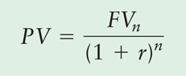

Future Value of an Ordinary Annuity
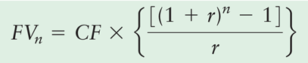

Present Value of an Ordinary Annuity
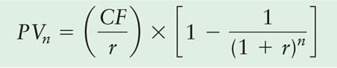

Future Value of an Annuity Due
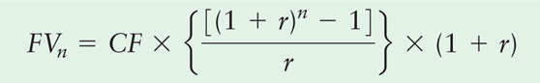

Present Value of an Annuity Due
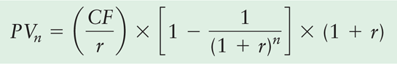

Present Value of a Perpetuity

Compounding Interest More Frequently Than Annually
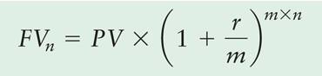

Continuous Compounding
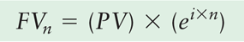

Effective Annual Rates of Interest
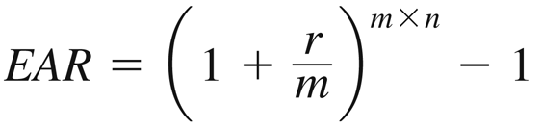

Finding Interest or Growth Rates
